Assignment 12.3

NAME :- P.CHARAN KUMAR
ROLL NO :- 2303A52138
BATCH :- 41

Task 1: Sorting Student Records for Placement Drive Scenario

import random
import string import time import copy

#
# Student Class #
class Student:
def init (self, name, roll, cgpa): self.name = name
self.roll = roll self.cgpa = cgpa

def repr (self):
return f"{self.name} | {self.roll} | CGPA: {self.cgpa}"

#
# Generate Large Dataset #
def generate_students(n): students = []
for i in range(n):
name = ''.join(random.choices(string.ascii_uppercase, k=5)) roll = f"SRU{i:05d}"
cgpa = round(random.uniform(5.0, 10.0), 2)

students.append(Student(name, roll, cgpa)) return students

#
# Quick Sort (Descending CGPA) #
def quick_sort(arr): if len(arr) <= 1:
return arr

pivot = arr[len(arr)//2].cgpa
left = [x for x in arr if x.cgpa > pivot] middle = [x for x in arr if x.cgpa == pivot] right = [x for x in arr if x.cgpa < pivot]

return quick_sort(left) + middle + quick_sort(right)

#
# Merge Sort (Descending CGPA) #
def merge_sort(arr): if len(arr) <= 1:
return arr

mid = len(arr) // 2
left = merge_sort(arr[:mid]) right = merge_sort(arr[mid:])

return merge(left, right)

def merge(left, right): result = []
i = j = 0

while i < len(left) and j < len(right): if left[i].cgpa > right[j].cgpa:
result.append(left[i])

i += 1
else:
result.append(right[j]) j += 1

result.extend(left[i:]) result.extend(right[j:])

return result

#
# Display Top 10 Students #
def display_top_10(sorted_students): print("\nTop 10 Students Based on CGPA:\n") for student in sorted_students[:10]:
print(student)

#
# Main Execution #
if name == " main ":
n = 50000 # Large dataset size students = generate_students(n)

# Quick Sort Test
students_qs = copy.deepcopy(students) start = time.time()
sorted_qs = quick_sort(students_qs) end = time.time()
quick_time = end - start
print(f"Quick Sort Time: {quick_time:.4f} seconds")

# Merge Sort Test
students_ms = copy.deepcopy(students) start = time.time()
sorted_ms = merge_sort(students_ms) end = time.time()

merge_time = end - start
print(f"Merge Sort Time: {merge_time:.4f} seconds")

# Show Top 10 (from Quick Sort result) display_top_10(sorted_qs)

# Performance Comparison print("\nPerformance Comparison:") print(f"Quick Sort: {quick_time:.4f} sec") print(f"Merge Sort: {merge_time:.4f} sec")

Output
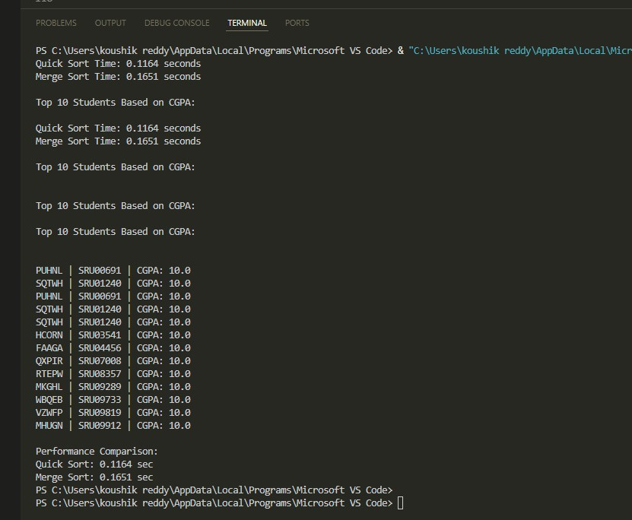

Task 2

def bubble_sort(arr):
n = len(arr)

# Outer loop controls the number of passes
# After each pass, the largest unsorted element
# moves ("bubbles") to its correct position at the end for i in range(n):

# Flag to check if any swap happens in this pass # If no swaps occur, array is already sorted swapped = False

# Inner loop compares adjacent elements
# We reduce range by 'i' because last 'i' elements # are already sorted after each pass
for j in range(0, n - i - 1):

# Compare adjacent elements
# If current element is greater than next, # swap them to maintain ascending order
if arr[j] > arr[j + 1]:

# Swapping elements
arr[j], arr[j + 1] = arr[j + 1], arr[j]

# Mark that a swap occurred swapped = True

# If no elements were swapped in this pass,
# the array is already sorted → terminate early if not swapped:
break

return arr

# Example usage
numbers = [64, 34, 25, 12, 22, 11, 90]
sorted_numbers = bubble_sort(numbers)

print("Sorted Array:", sorted_numbers)

Output

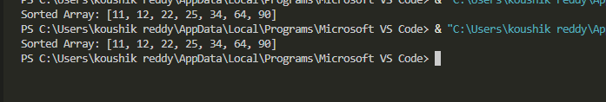

Task 3 Quick Sort and Merge Sort Comparison

import random
import time import sys

# Increase recursion limit for large lists sys.setrecursionlimit(10**6)

#
# Quick Sort (Recursive) #
def quick_sort(arr): """
Performs Quick Sort using recursion.

Parameters:
arr (list): List of comparable elements.

Returns:
list: New sorted list (ascending order).

Algorithm:
- Select a pivot (middle element).
- Partition elements into:
left -> elements smaller than pivot equal -> elements equal to pivot right -> elements greater than pivot
- Recursively sort left and right.
"""
if len(arr) <= 1: return arr

pivot = arr[len(arr) // 2]

left = [x for x in arr if x < pivot] middle = [x for x in arr if x == pivot] right = [x for x in arr if x > pivot]

return quick_sort(left) + middle + quick_sort(right)

#
# Merge Sort (Recursive) #
def merge_sort(arr): """
Performs Merge Sort using recursion.

Parameters:
arr (list): List of comparable elements.

Returns:
list: Sorted list (ascending order).

Algorithm:
- Divide array into two halves.
- Recursively sort both halves.

- Merge sorted halves.
"""
if len(arr) <= 1: return arr

mid = len(arr) // 2
left = merge_sort(arr[:mid]) right = merge_sort(arr[mid:])

return merge(left, right)

def merge(left, right): """
Merges two sorted lists into one sorted list. """
result = [] i = j = 0

while i < len(left) and j < len(right): if left[i] < right[j]:
result.append(left[i]) i += 1
else:
result.append(right[j]) j += 1

result.extend(left[i:]) result.extend(right[j:])

return result

#
# Performance Comparison #
def test_algorithms(data, label):
print(f"\nTesting on {label} list (size = {len(data)})") # Quick Sort

start = time.time() quick_sort(data)
quick_time = time.time() - start

# Merge Sort
start = time.time() merge_sort(data)
merge_time = time.time() - start

print(f"Quick Sort Time: {quick_time:.6f} sec") print(f"Merge Sort Time: {merge_time:.6f} sec")

#
# Main Execution #
if name == " main ": n = 10000

random_list = [random.randint(1, 100000) for _ in range(n)] sorted_list = sorted(random_list)
reverse_sorted_list = sorted(random_list, reverse=True)

test_algorithms(random_list, "Random") test_algorithms(sorted_list, "Sorted") test_algorithms(reverse_sorted_list, "Reverse Sorted")

Output
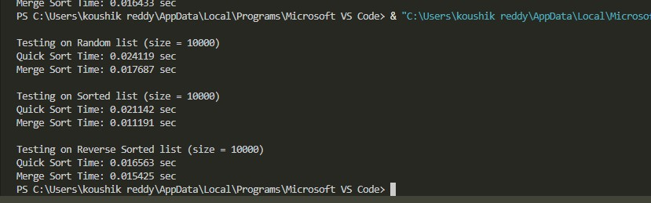

Task 4

(Real-Time Application – Inventory Management System)

Product class

class Product:
def init (self, product_id, name, price, quantity): self.product_id = product_id
self.name = name
self.price = price
self.quantity = quantity

def repr (self):
return f"{self.product_id} | {self.name} | ₹{self.price} | Stock:
{self.quantity}"

Product class

class Inventory:
def init (self):
# Hash tables for fast search
self.products_by_id = {}
self.products_by_name = {}

def add_product(self, product): # O(1) insertion
self.products_by_id[product.product_id] = product
self.products_by_name[product.name.lower()] = product

#
# Searching #
def search_by_id(self, product_id):

"""
Search product using hash table lookup.
Time Complexity: O(1) average """
return self.products_by_id.get(product_id, "Product not
found")

def search_by_name(self, name): """
Search product by name using hash table.
Time Complexity: O(1) average """
return self.products_by_name.get(name.lower(), "Product not
found")

#
# Sorting #
def sort_by_price(self): """
Sort products by price using Python's Timsort. Time Complexity: O(n log n)
"""
return sorted(self.products_by_id.values(), key=lambda x:
x.price)

def sort_by_quantity(self): """
Sort products by stock quantity. Time Complexity: O(n log n)
"""
return sorted(self.products_by_id.values(), key=lambda x:
x.quantity)

Example Usage

class Inventory:
def init (self):
# Hash tables for fast search

self.products_by_id = {}
self.products_by_name = {}

def add_product(self, product): # O(1) insertion
self.products_by_id[product.product_id] = product
self.products_by_name[product.name.lower()] = product

found")
#
# Searching #
def search_by_id(self, product_id): """
Search product using hash table lookup.
Time Complexity: O(1) average """
return self.products_by_id.get(product_id, "Product not

found")
def search_by_name(self, name): """
Search product by name using hash table.
Time Complexity: O(1) average """
return self.products_by_name.get(name.lower(), "Product not

x.price)
#
# Sorting #
def sort_by_price(self): """
Sort products by price using Python's Timsort. Time Complexity: O(n log n)
"""
return sorted(self.products_by_id.values(), key=lambda x:

def sort_by_quantity(self): """

Sort products by stock quantity. Time Complexity: O(n log n)
"""
return sorted(self.products_by_id.values(), key=lambda x:
x.quantity)

Output

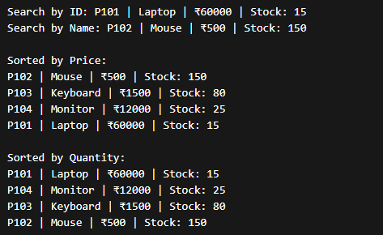

Task 5 : Real-Time Stock Data Sorting & Searching

import random
import string import time import heapq

#
# Stock Class #
class Stock:

def init (self, symbol, open_price, close_price): self.symbol = symbol
self.open_price = open_price
self.close_price = close_price
self.change_percent = ((close_price - open_price) /
open_price) * 100

def repr (self):
return f"{self.symbol} | Open: {self.open_price:.2f} | Close: {self.close_price:.2f} | Change: {self.change_percent:.2f}%"

k=4))
#
# Generate Random Stock Data #
def generate_stocks(n): stocks = []
for _ in range(n):
symbol = ''.join(random.choices(string.ascii_uppercase,

open_price = random.uniform(100, 1000) close_price = random.uniform(100, 1000)
stocks.append(Stock(symbol, open_price, close_price)) return stocks

#
# Heap Sort (Based on % Change) #
def heap_sort(stocks): """
Sort stocks in descending order based on percentage change. Time Complexity: O(n log n)
"""
heap = []

for stock in stocks:
# Using negative value for max-heap behavior heapq.heappush(heap, (-stock.change_percent, stock))

sorted_stocks = [] while heap:
sorted_stocks.append(heapq.heappop(heap)[1]) return sorted_stocks

#
# Hash Map Search #
def build_hash_map(stocks): """
Build dictionary for O(1) stock lookup. """
stock_map = {}
for stock in stocks: stock_map[stock.symbol] = stock
return stock_map

def search_stock(stock_map, symbol): """
Search stock instantly using hash map.
Time Complexity: O(1) average """
return stock_map.get(symbol, "Stock not found")

#
# Performance Comparison #
if name == " main ": n = 20000
stocks = generate_stocks(n)

# Build Hash Map
stock_map = build_hash_map(stocks)

#
# Heap Sort Timing

#
start = time.time()
heap_sorted = heap_sort(stocks) heap_time = time.time() - start

#
# Python Built-in Sort Timing #
start = time.time()
built_in_sorted = sorted(stocks, key=lambda x: x.change_percent, reverse=True)
builtin_time = time.time() - start

#
# Search Timing #
random_symbol = stocks[n//2].symbol

start = time.time()
result = search_stock(stock_map, random_symbol) search_time = time.time() - start

print("Heap Sort Time:", heap_time) print("Built-in Sort Time:", builtin_time) print("Search Time (Hash Map):", search_time)

print("\nTop 5 Gainers:")
for stock in heap_sorted[:5]: print(stock)

print("\nSearch Result:") print(result)

Output

